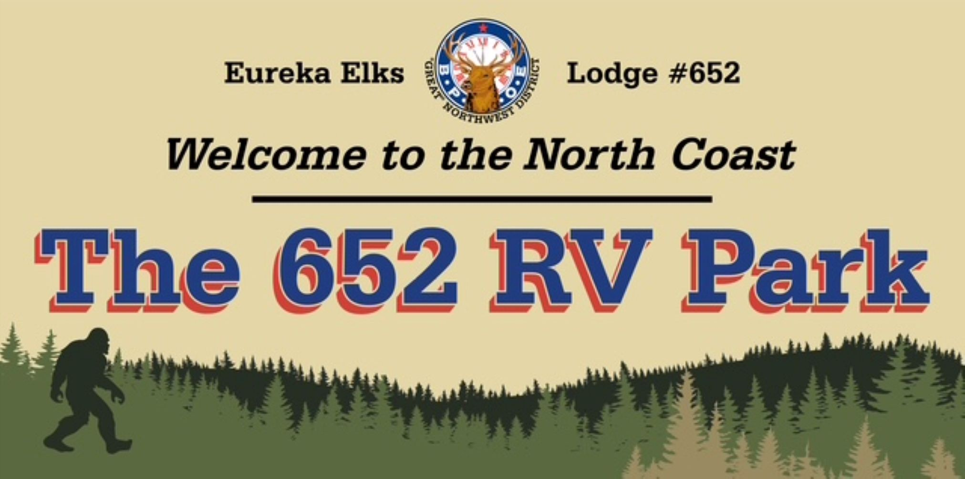
RV PARK RULES
- The RV Lot is for the sole use of ELKS in good standing, sorry no guests allowed.
- Parking is limited to fourteen (14) consecutive days; the Lodge Trustees may permit exceptions. Contact the Lodge Secretary). for extended stat rules and rates.
- Towing vehicles or towed vehicles must be parked directly in front of your RV.
- Registration shall be completed in the reception office during open hours, or registrations will be accepted by the bartender in charge.
- Check in time is 2:00 p.m.
- Check out time is 11:00 a.m.
- POST RV PARKING PERMIT on or next to the main entrance door of RV, in window. It must be legible from the window.
- Conduct unbecoming to an ELK will be cause to revoke permit.
- PADS MUST be put under ALL TACKS on black top area.
- There is NO DRY CAMPING allowed on any PARKING LOTS.
- CAUTION! Multiple uses of electrical appliances can overload the Lodge electrical system.
- NO WASHING allowed of RV's or any vehicles.
- The operation of generators is not permitted.
- The pet area is located at north end of RV Park, pet droppings must be picked up and disposed of in a trash receptacle. Dogs must always be on leash. (Ordinance enforced by Humboldt County).
- Hats and caps are not to be worn at any time in the Eureka Lodge.
- This property is privately owned by the Eureka Elks. We reserve the right to refuse service to anyone and will not be responsible for accidents or injuries to our guests or for loss of money or valuables of any kind.
USE AGREEMENT FOR RVS: In consideration of being allowed to park my unit in the appropriate area designated by the Lodge, I hereby agree to indemnify and save harmless the Lodge from any and all claims and expenses arising out of my parking or use of the facilities, except for the sole negligence of the Lodge. I further agree that no claim for damage to my property will be made against the Lodge under any circumstances and that any rights of subrogation for damage to my property are waived.

